Pentecost 15 8/24/08 “And so, “Who do You Say Jesus is?”
––Matthew 16:13-17

I. INTRODUCTION.

If you’re like me, you like jokes about politicians –– one of my favorites is this one: Question… What’s the difference between a car accident involving a rabbit and one involving a politician? Answer… There are skid marks leading up to the rabbit.

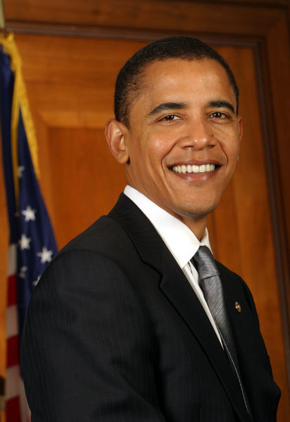

Here are some familiar politicians –– Barack Obama and John McCain who are running for President; Al Franken and Norm Coleman who are running for Senate. Ironically, even though they are in total disagreement on a number of key issues, each candidate sincerely believes that he is the best person for the job. Each candidate is convinced that his policies and character are what America needs. All of them are highly intelligent. Each candidate can be extremely charming. All of them have made mistakes in the past and learned from them. So who do you pick? Do you pick someone because of the political party they belong to? I’d say that’s risky in light of the fact that it doesn’t take into consideration the character and values of the candidate.

We like to make fun of politicians because they live in glass houses, but the truth is most of them are good people trying to serve their country. It’s also important to realize that Christians need to be involved in the political process, both as voters and as elected officials. Jesus directed us to do this when He said, “You are the salt of the earth.” ––Matthew 5:13 Salt was used in Jesus’ day to prevent the rotting of meat. We are the salt of the earth today when we prevent the moral decay of our culture. Being involved in the political process is one way to help prevent spiritual rot in our society.

Some words of caution about the upcoming elections: first, don’t base your vote on 30-second sound bites or degrading attack ads because they don’t reveal a politician’s true character; and don’t let comedians like Jay Leno, David Letterman or Jon Stewart influence how you should vote. Instead, ask God to guide you; second, take the time to study the issues and so I would also encourage you to watch the upcoming debates to get a feel for which candidates best represent your values; and third, get out there and vote on November 4th. One of the beauties of living in a democracy is we can have different opinions regarding the issues and still be unified as one nation.

II. SIMILARITIES BETWEEN POLITICS AND FAITH.

Much of what I’ve just said about politics can also be said about matters of faith. People should not be coerced into believing in Jesus; they need to come to faith by their own free will. Faith in Christ should never be based on what you hear on a radio talk show or from a sound-bite or some network special. If people would take the time to look carefully at who Jesus is, then they can make informed decisions in regards to such vital questions as, ‘Who is Jesus Christ?’ and ‘Did He really rise from the dead?’ It is important that we take the time to investigate. Rejecting Jesus without getting the facts is simply not fair. This brings us to the first question that Jesus asks in our text…

III. WHO DO PEOPLE SAY THE SON OF MAN IS?

Jesus presents this question to Peter and the others at Caesarea Philippi. It is important to understand why Jesus asked this question at this particular time. Caesarea Philippi was a Greco-Roman city about 13 miles north of Galilee; it was an international city, a center of trade and commerce, a crossroads of the Middle East. Its original name was “Paneas,” a city dedicated to the worship of Pan. Pan was usually depicted with the head, chest and arms of a man and with the legs, horns and ears of a goat. Pan prances through the fertile countryside playing his seven-reed pipe in wild abandon. His piping can be as soft and seductive as the breeze, but when he’s angered, his howl can be heard for miles. It’s been a long time since anyone has spotted Pan –– perhaps those hunters who found ‘Bigfoot’ last week could help.
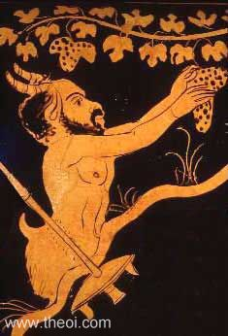
Caesarea Philippi had also become a marketplace of various gods and cults, all contending for the loyalty of this international city. Caesarea Philippi was much like the modern world we live in where there is no one religion or church that dominates our lives. Rather our world is a marketplace of ideas and faiths, each competing for believers. To get a sense of what I’m talking about, take the Yellow Pages sometime and look under the heading of ‘Churches’. You will be amazed at the number and variety of churches and religions that are listed there.

You’ll notice in our text that Jesus does not ask His disciples, “WHAT RELIGION DO PEOPLE BELONG TO?” That’s not the question. Rather, He asks His disciples, “WHO DO PEOPLE SAY THE SON OF MAN IS?” The answers were predictable — “Maybe he’s John the Baptist, or Elijah, or Jeremiah, or one of the prophets…” All they could do was try to fit Jesus into categories of thought that already existed. In other words, “Let’s try to cram this Jesus into our pre-conceived notions about such things. Maybe He’s a prophet! Or, hey, remember that John the Baptist? He was a strange one! Maybe He’s John the Baptist come back to life!” We see the same thing today. There are a multitude of opinions out there about Jesus, and they all fit into pre-conceived notions which are based on what others have said about Jesus. For example…
- He was a great prophet;
- He was an incredible man who was more enlightened than most;
- He was an ancient Jewish version of Gandhi;
- He was a political radical;
- He was a religious zealot;
- He was a magician—his miracles were all tricks.

And the list goes on. All of these answers to our Lord’s question –– “WHO DO PEOPLE SAY THE SON OF MAN IS?” –– fit into predetermined categories, rather than letting Jesus Christ, Himself, redefine our categories by His true identity. Too often we simply listen to the polls. Just like bad journalists, we fail to go to the sources. We rely on hearsay, on unconfirmed evidence, and anything that sounds “juicy.” It’s not that our culture has no interest in Jesus. Every Christmas and Easter all the main news magazines run cover stories on Jesus, and the TV networks run specials on Jesus. But much of what is said is unconfirmed hearsay and scandalous. Who do people say the Son of Man is? Could be almost anything today.

This means we need to be careful about where we get our information about Jesus. You even need to be careful about which church you attend. In many churches Jesus has been watered down to being a Genie in a Bottle. People use Jesus whenever they need something. You’ll hear preachers preaching on how to demand what you want from the Lord. That’s called PROSPERITY GOSPEL which is the idea that God wants all of us to be rich and healthy and if you’re not rich and healthy, then you’re doing something wrong. Tell that to the Christians living under persecution in North Korea, Sudan, China and India. Much of the preaching today in America is about Prosperity, not salvation. Some preachers don’t even preach from the Bible anymore. And so their flocks are left to follow the polls of popular opinion instead of the clear teachings of God’s Word.

We should not be surprised by what we see today. Keep in mind that they got it wrong in Jesus’ day as well. The title, “Christ” is the Greek form of the ancient Hebrew word, “Messiah”. The Messiah is another word for the “anointed” King of God’s people. The prophets pointed toward a time when the Kingdom of God would come in splendor, with the Messiah as the King of kings and Lord of lords. God would be their God and they would be His people in this perfect kingdom. But what’s really interesting is that the Jews of Peter’s time were looking for the Messiah to set up an earthly kingdom — that he would rule as King in such a way that the tables would be turned on the Romans. They thought the Messiah would kick the Romans out of the land and in turn that the Israelites would rule over them! However, the Jesus born in Bethlehem did not fit into any pre-conceived notions. We cannot push a cross-shaped block into a round hole. He was God in the Flesh, the Perfect Revelation of God. He is the Christ, the Messiah, the King –– but even in Peter’s day, the public opinion dictated otherwise.

Jesus now looks at the disciples and He says – “Okay, you have informed me as to what the polls are saying about me.” Jesus knows that more often than not, the polls don’t get it right. Just as we recognize during this election season that the polls don’t always get it right. Remember…
- The polls said Senator Hillary Clinton would be the Democratic nominee for President of the United States; and…
- The polls said former N.Y.C. Mayor, Rudy Giuliani, would be the Republican nominee for President of the United States –– obviously, the polls were wrong.

Are you following the polls? That’s okay. It’s good to know what’s going on in the world. But it is much better to be engaged ourselves. Jesus knows this and so He turns to His disciples and says ––

IV. “WHO DO YOU SAY THAT I AM?”

In answer to our Lord’s question Peter says, “You are the Christ, the Son of the living God.” That was a remarkable answer considering what the polls of his day were saying. Most polls would have concluded exactly the opposite. Public opinion would have said Peter was well-meaning but off-target. In fact, there is no record of the other disciples saying, “Yes! Peter’s right –– you are the Christ!” They all seem to have left Peter out on a limb, waiting for a response from Jesus.

V. THE MIRACLE OF FAITH.

Peter knows who Jesus is — but how did He arrive at the conclusion that Jesus was mankind’s Savior? He certainly didn’t discover it by listening to the latest polls. If he had listened to public opinion he, too, would have been led to believe that Jesus was just another prophet.

Our text reveals how Peter was able to say, “You are the Christ, the Son of the living God.” In verse 17 Jesus said, “Blessed are you, Simon son of Jonah, for this was not revealed to you by man, but by my Father in heaven.” There you have it! A true understanding of who Jesus is does not come from human nature, but from God alone working through His Word. If you miss this, you have no foundation on which to build your faith! Faith comes by hearing and hearing by the Word of God. There have been other religious leaders throughout the ages — great men in the eyes of those who follow them. But, my friends, there was only one Christ, only one Son of the Living God, only one Savior! He is the One who died for your sins and rose again. It is in Him that we put our trust. God grant it be so for Jesus’ sake. Amen!!!

